1. compress all files (name it to the project) 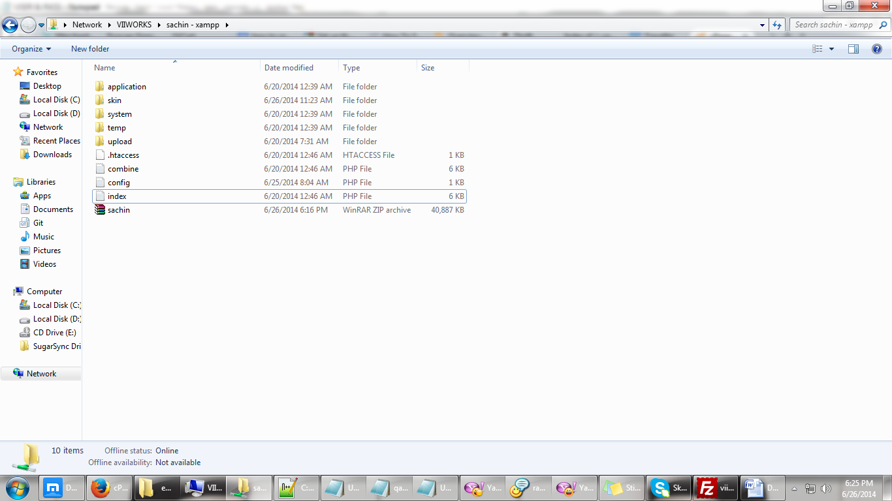

2. go to http://108.174.147.82/cpanel 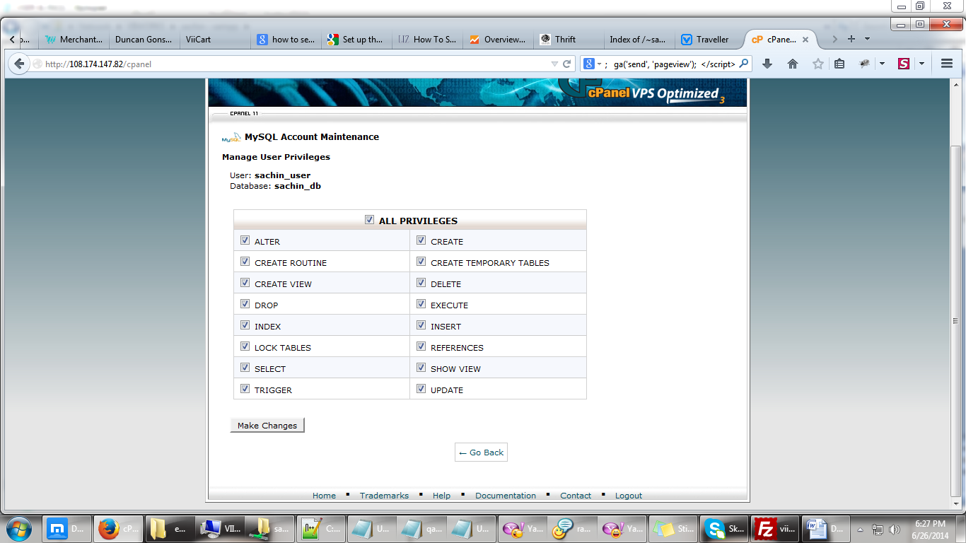

3. enter username & password 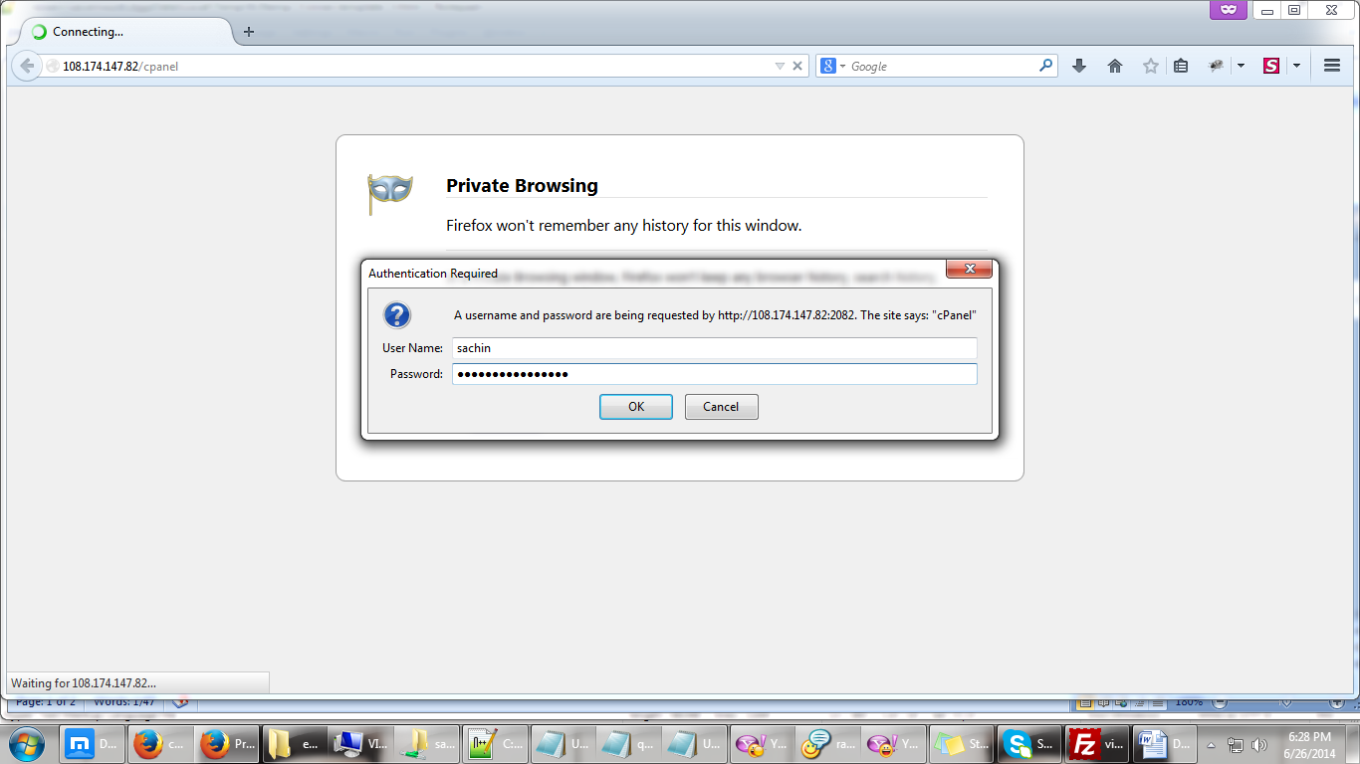

4. click MySQL Databases 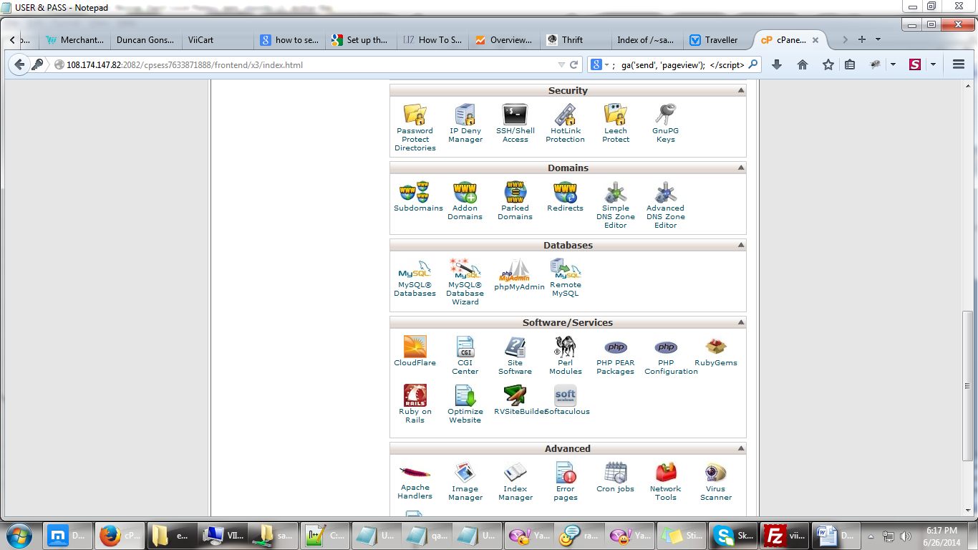

5. enter new database (always use “db”) 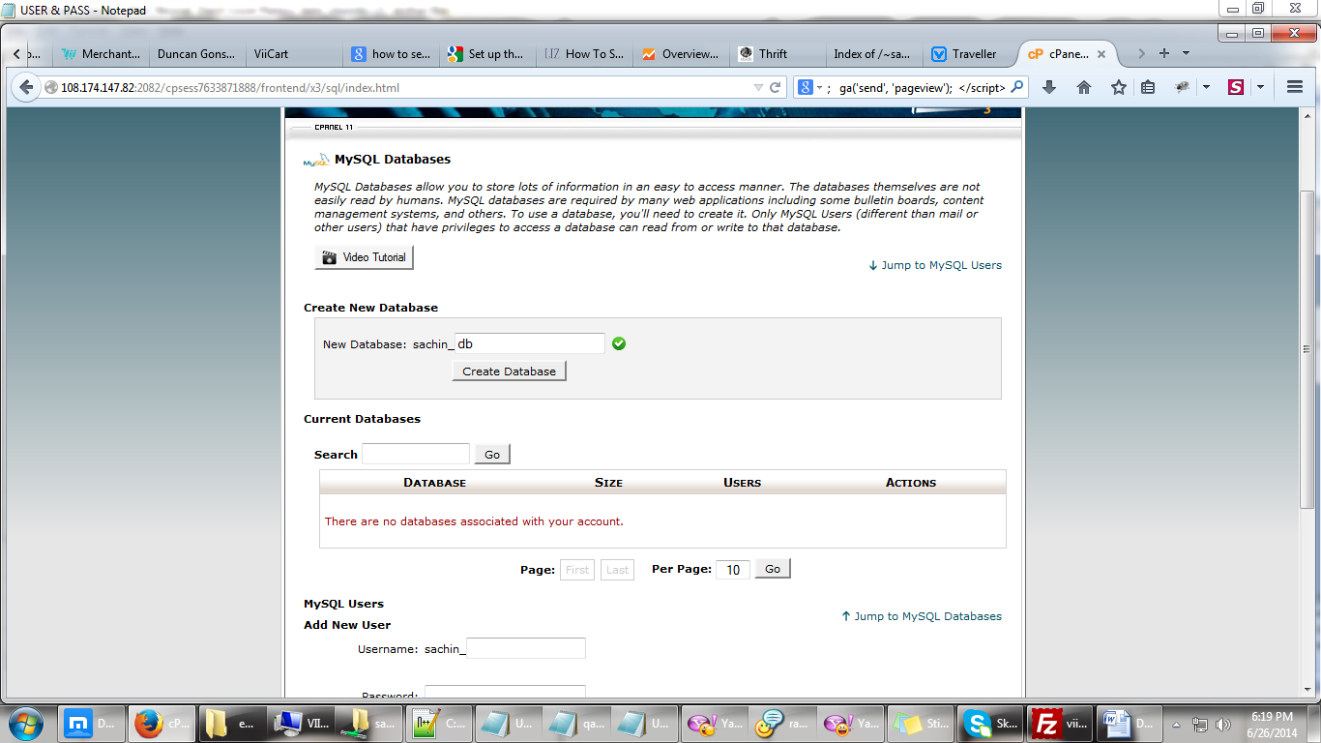

6. enter user database (always use “user”) 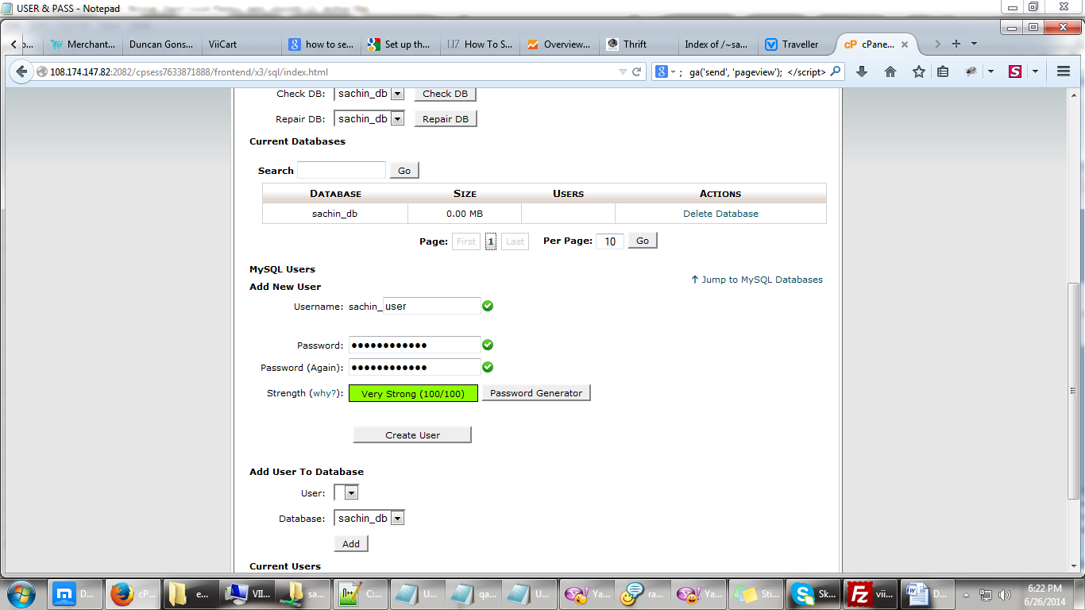

7. click Add 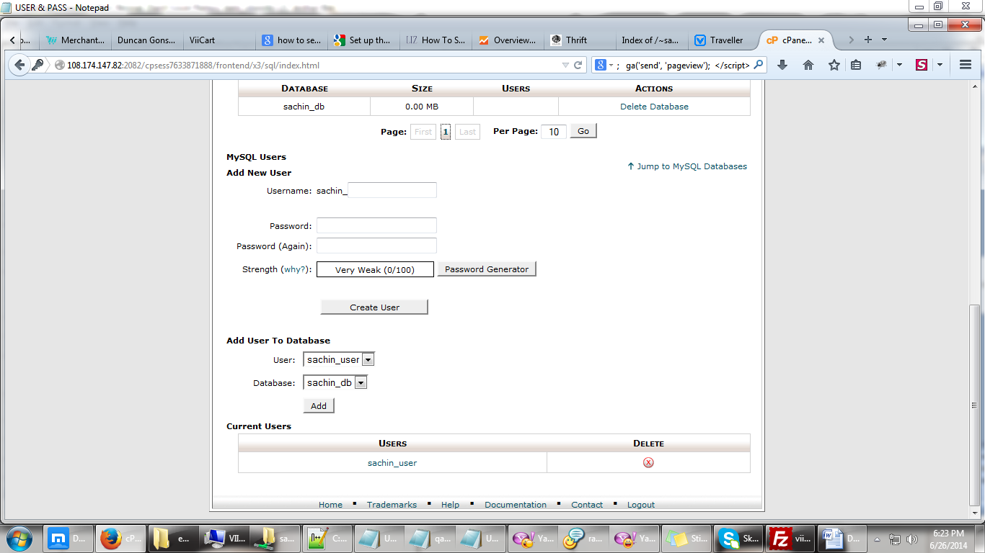

8. click ALL PRIVILAGES and Make Changes 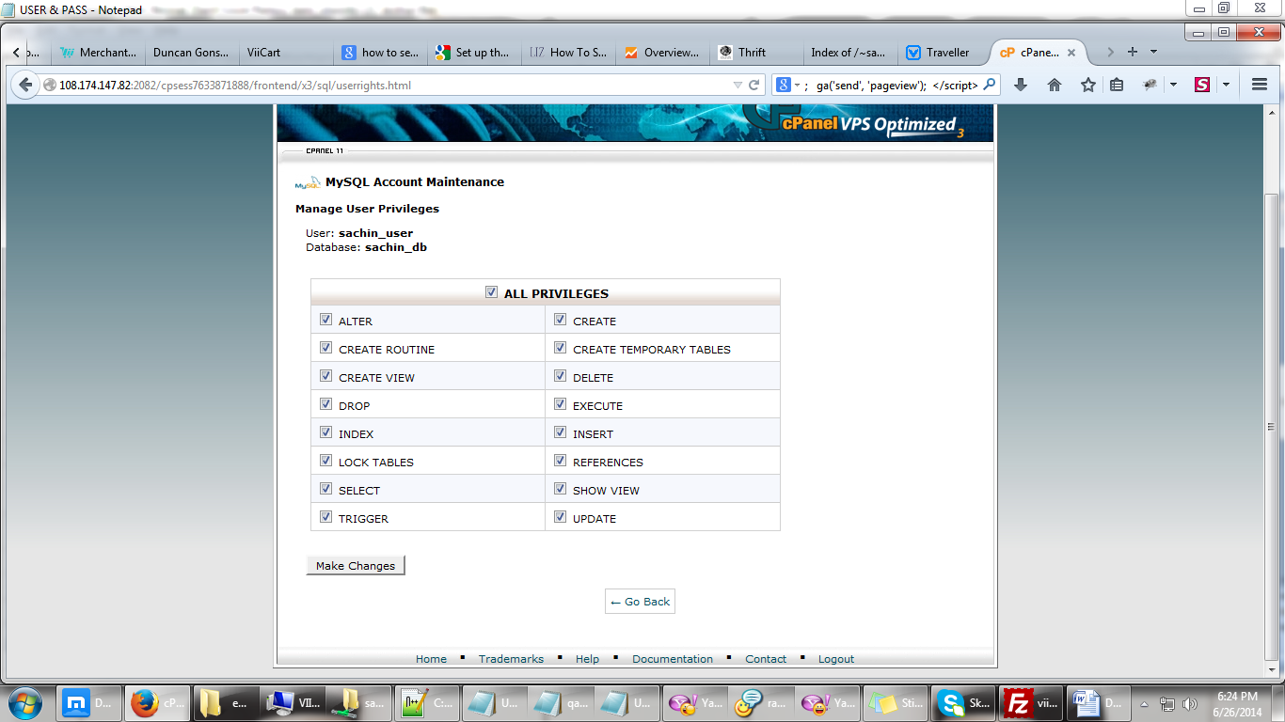

9. go back to Home (upper right) 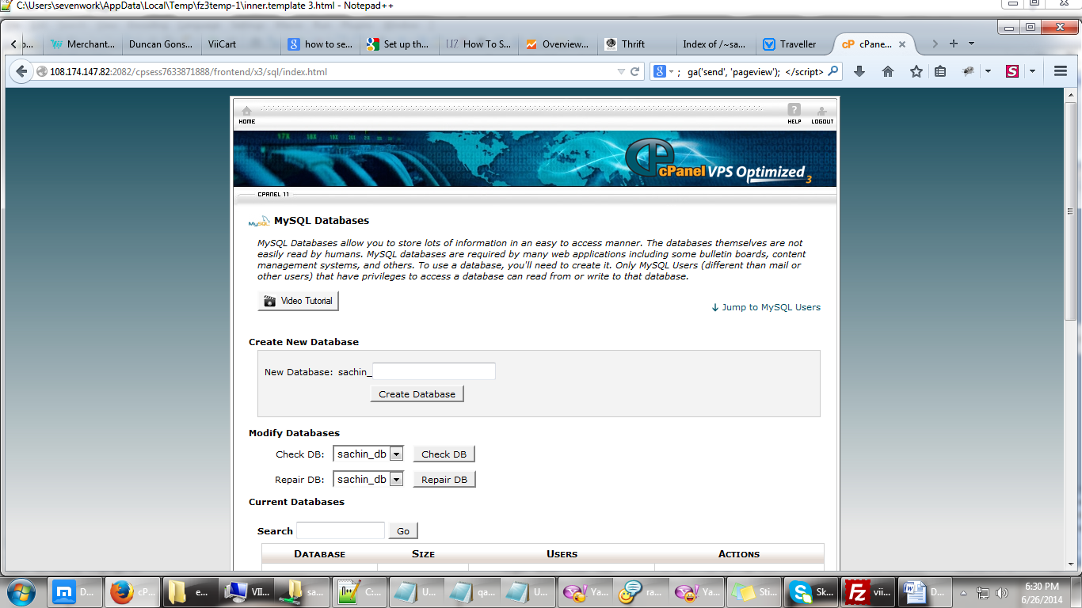

10. click phpMyAdmin 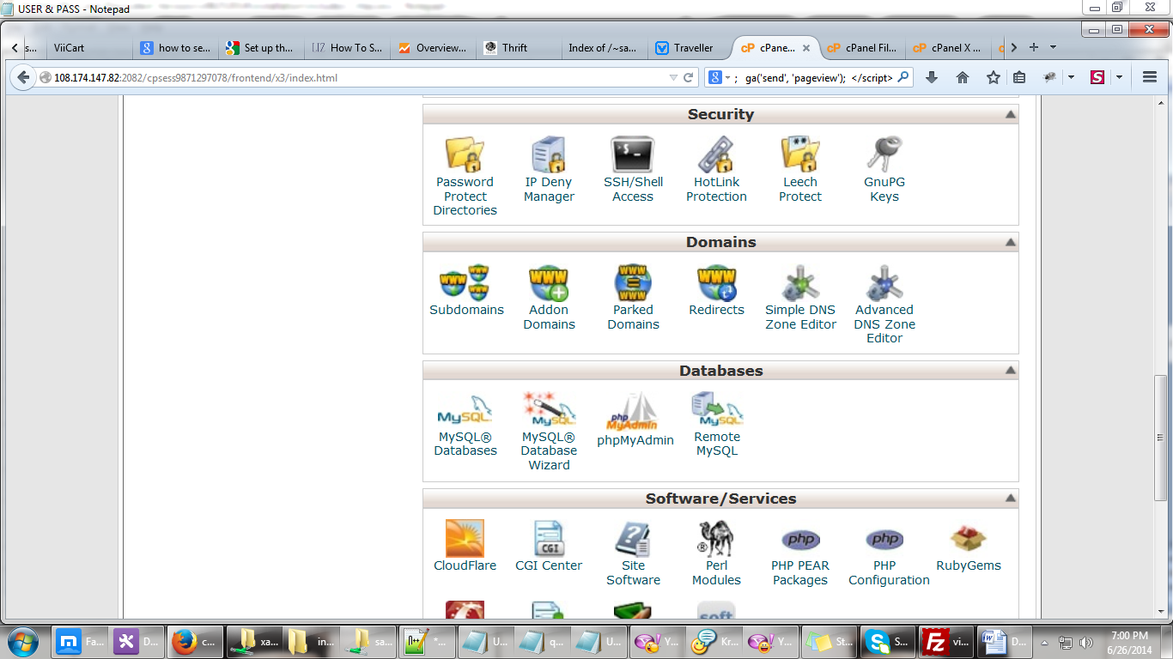

11. click the database created and Import 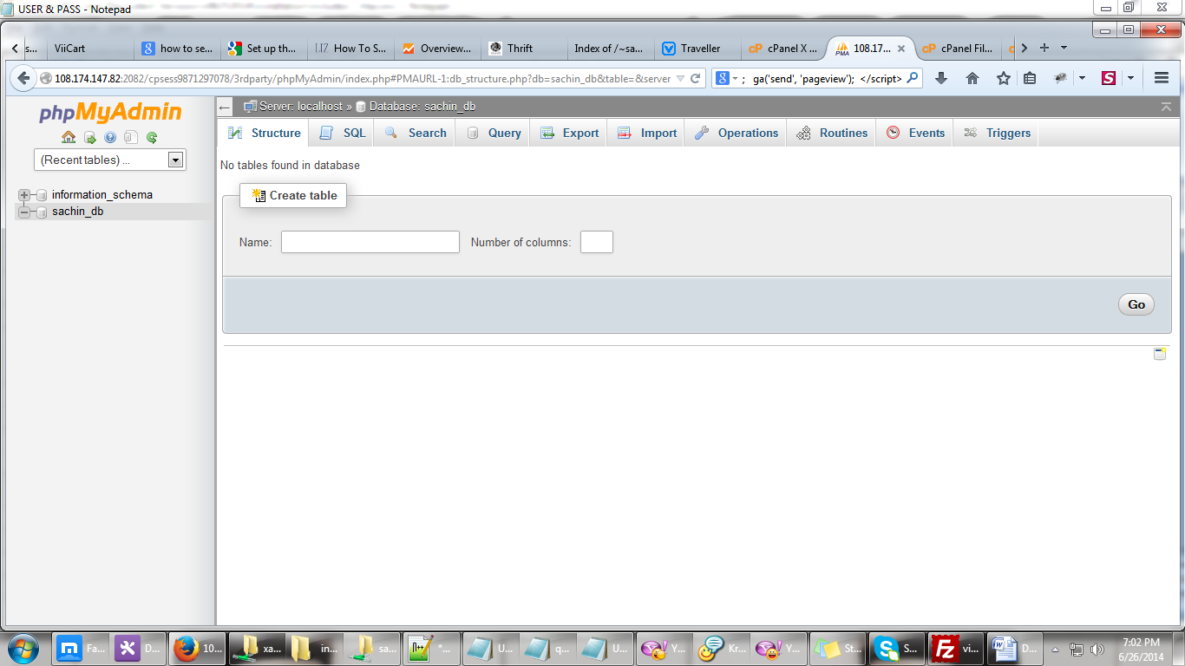 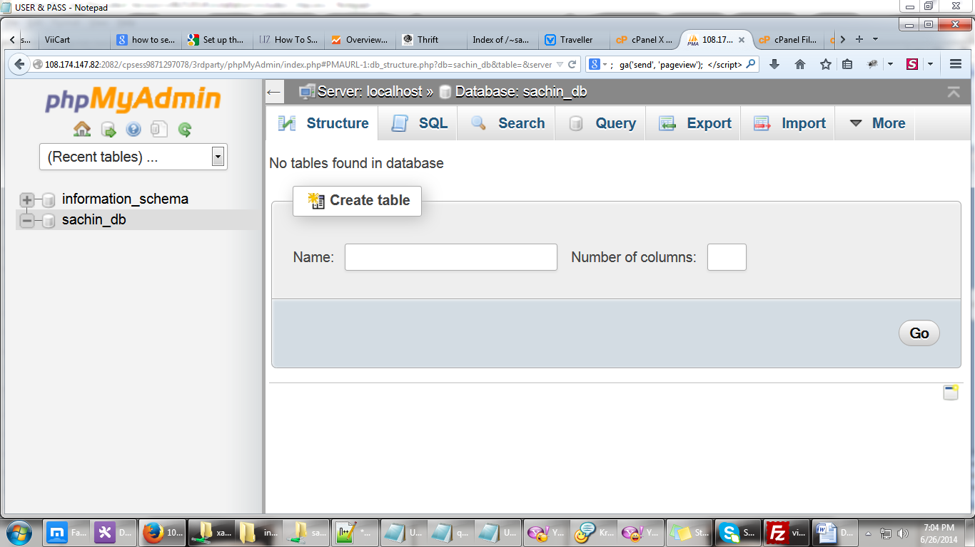

12. Click Browse then select the database from local file and click Go 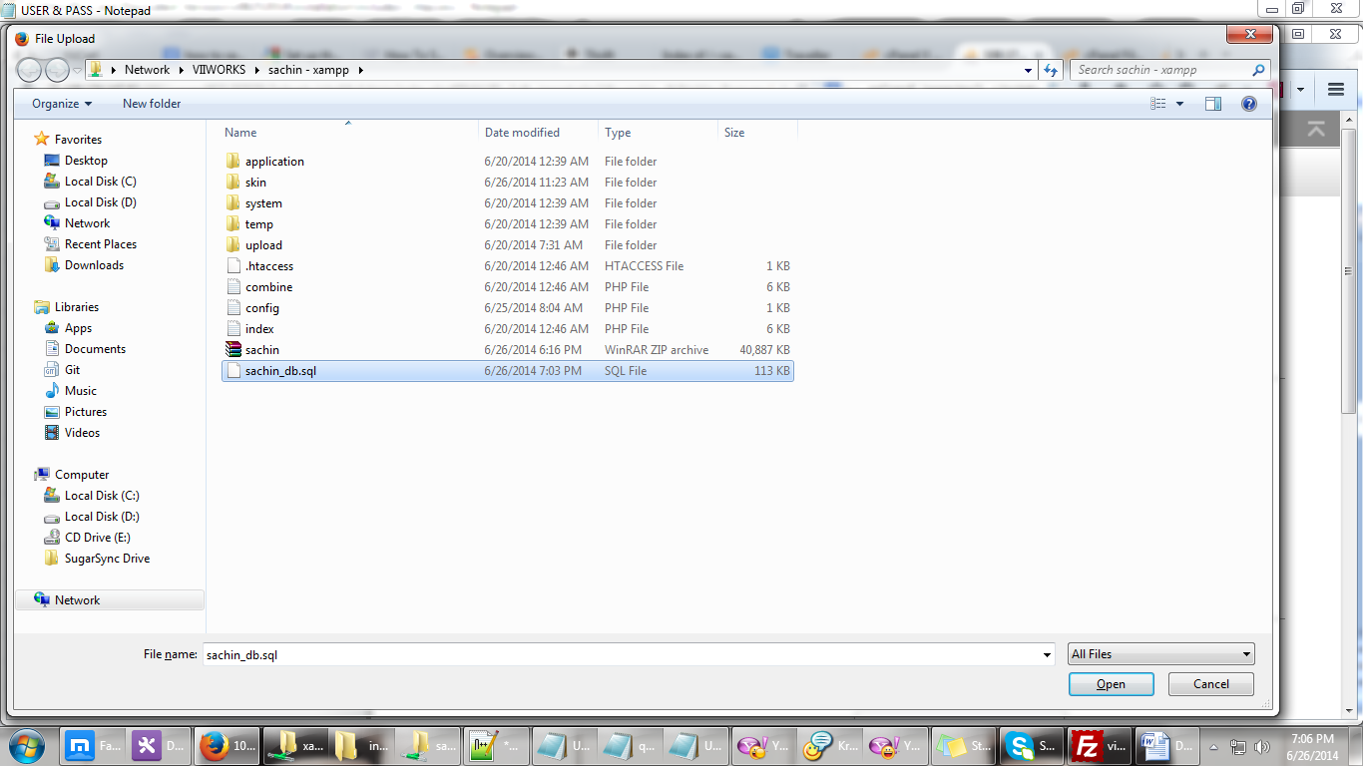 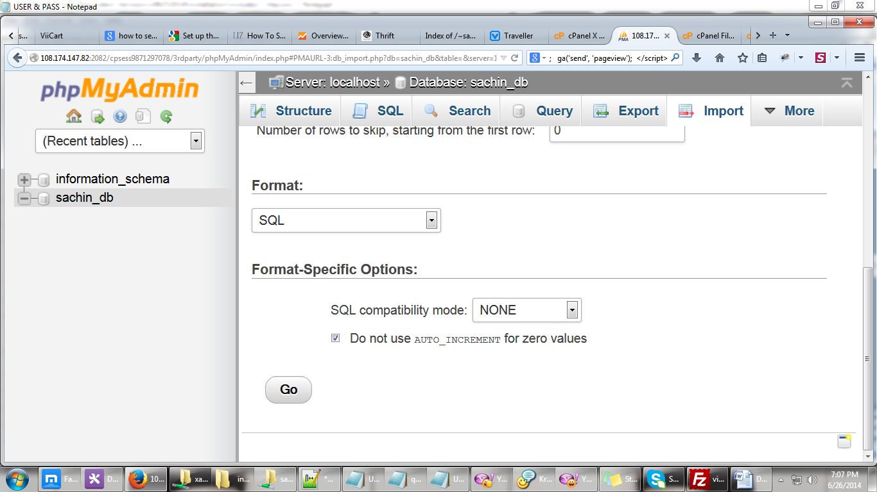

13. go back to Home and click File Manager 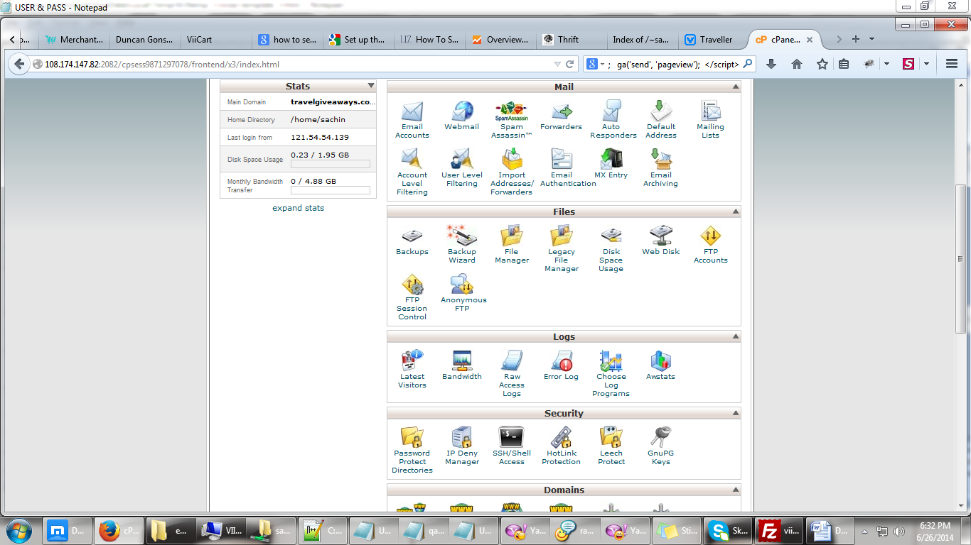

14. check “Show Hidden Files” and “Skip..” then click Go 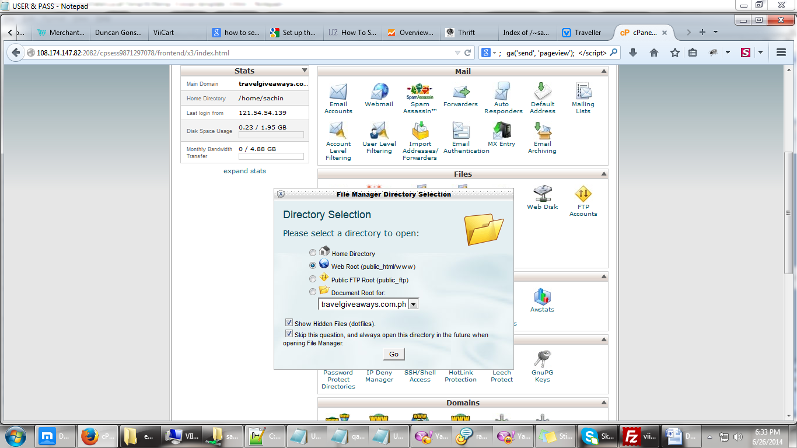

15. click Upload from File Manager Dashboard 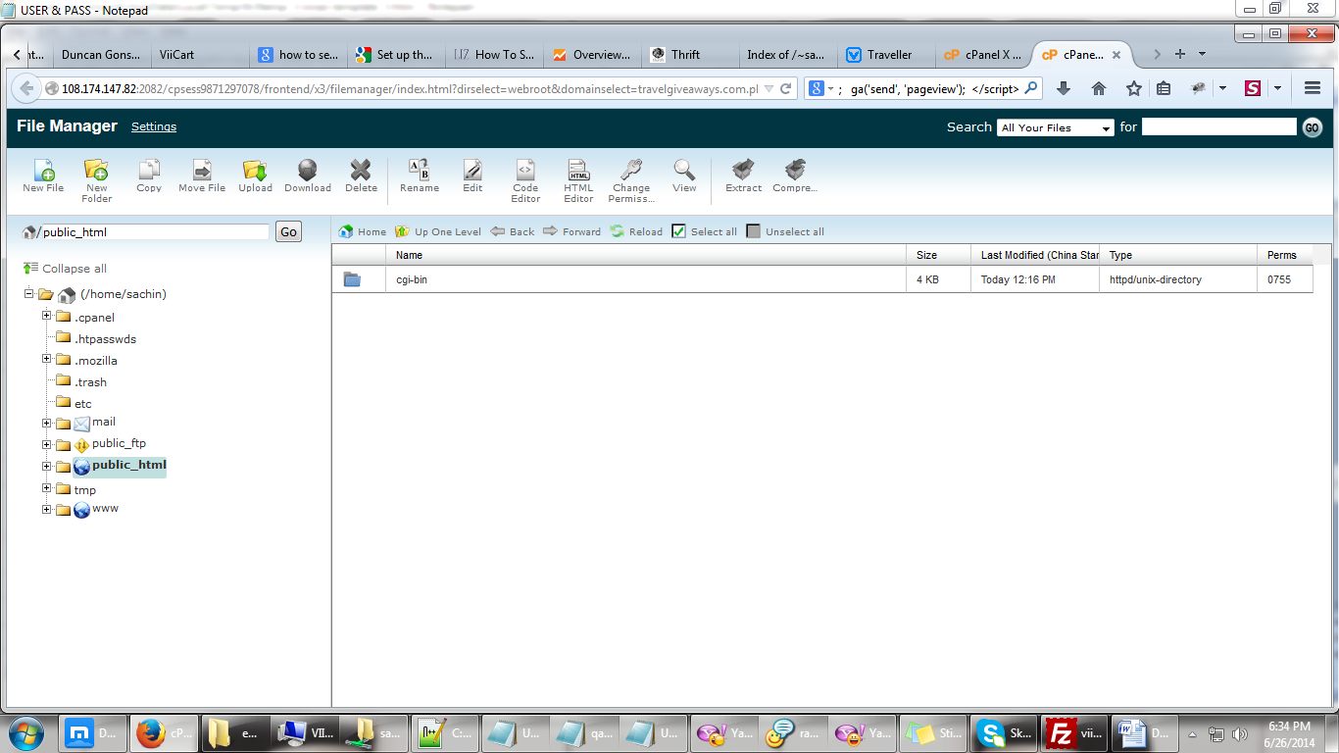

16. Select the project to be uploaded 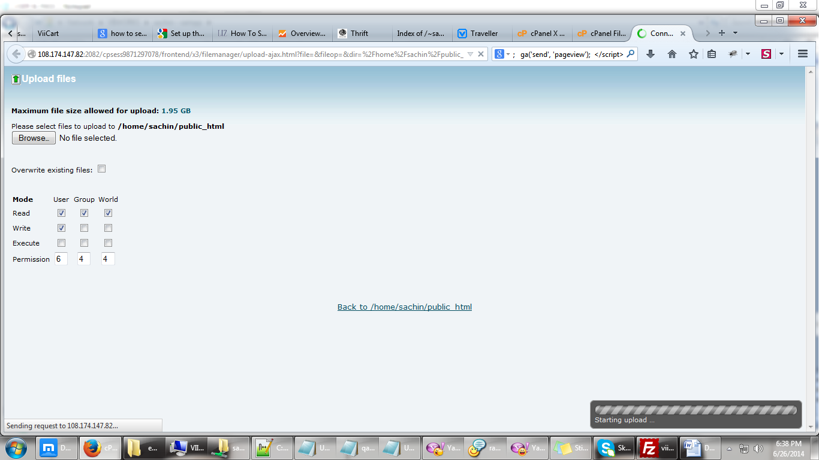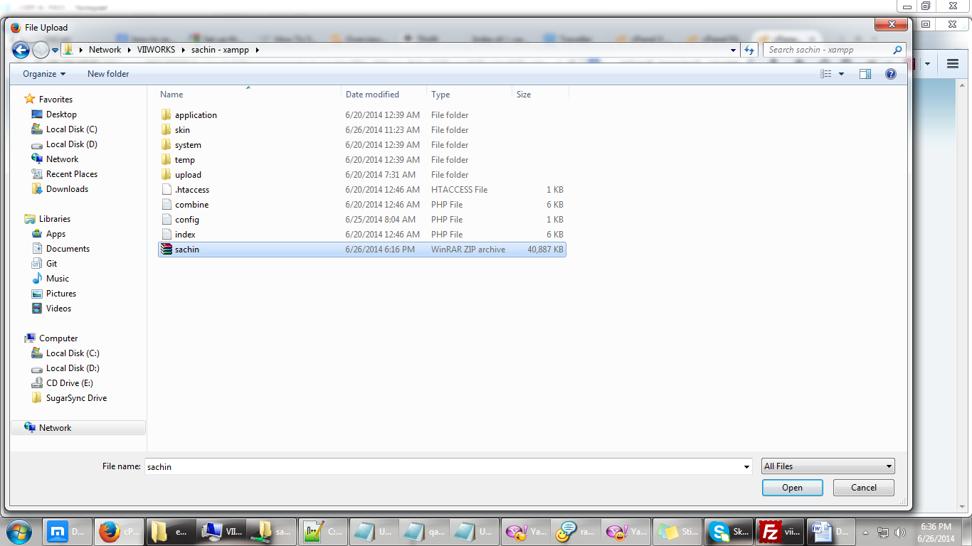

17. wait for the upload to complete 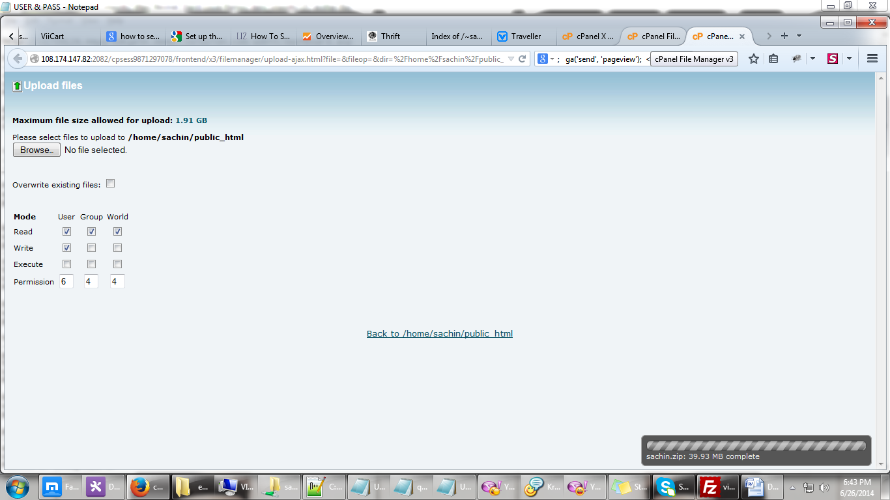

18. click Reload from the File Manager Dashboard 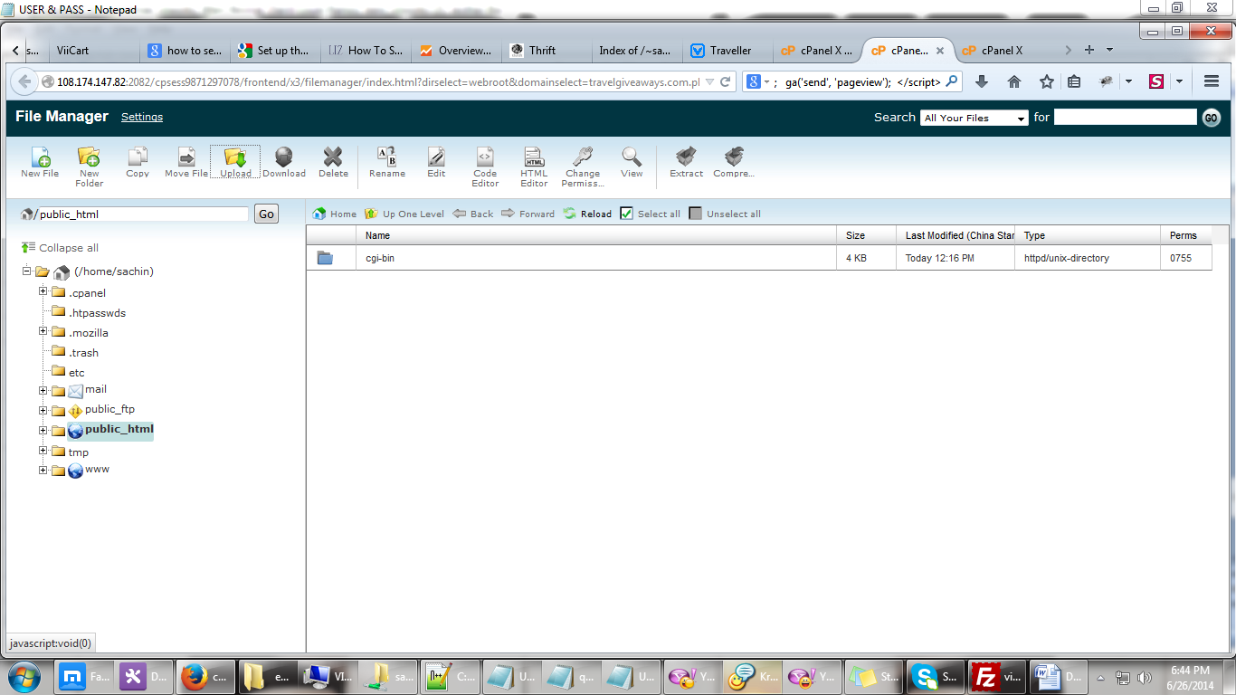

19. right click on the project and Extract 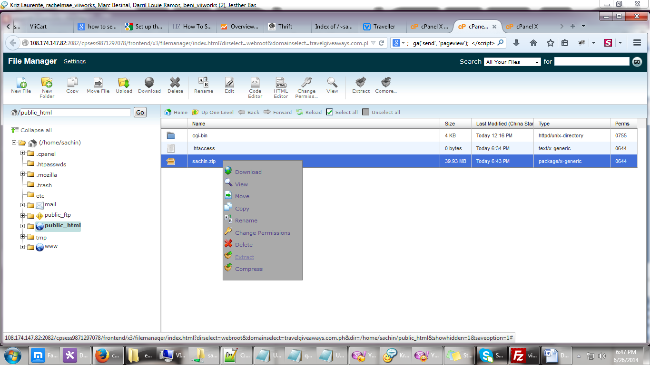

20. click Extract File(s) 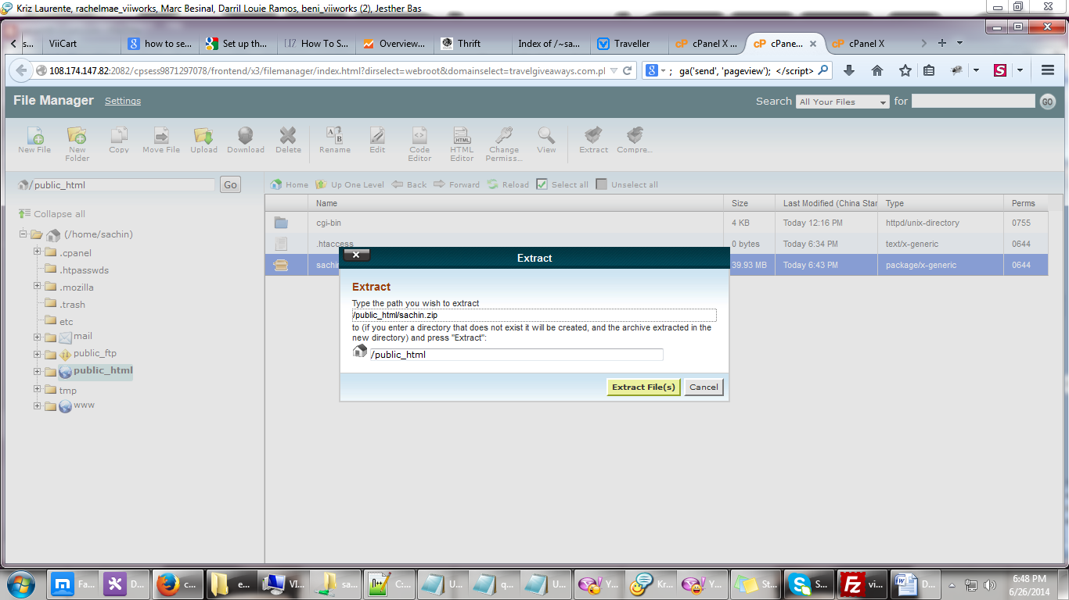

21.click close 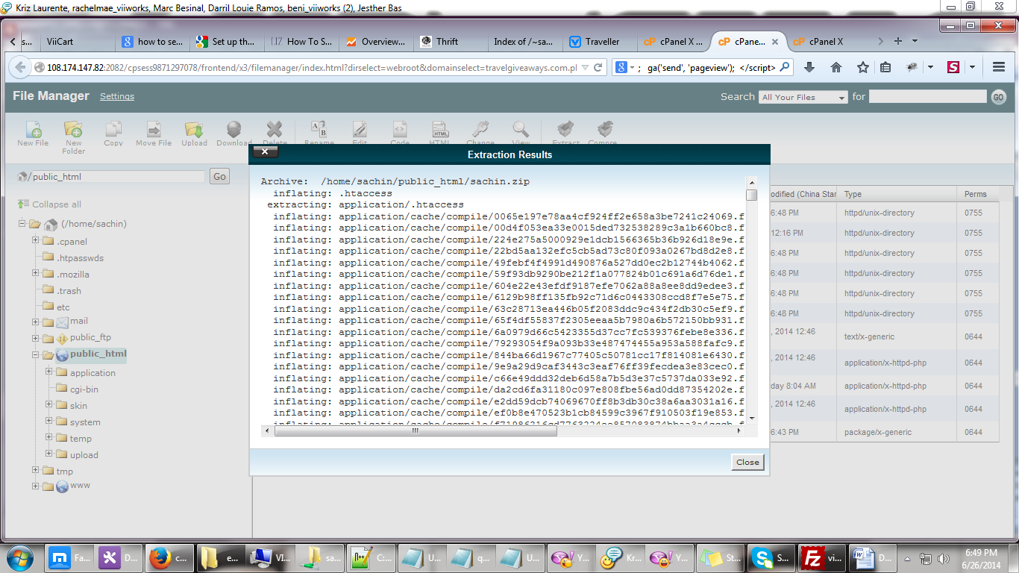

22. Edit .htaccess 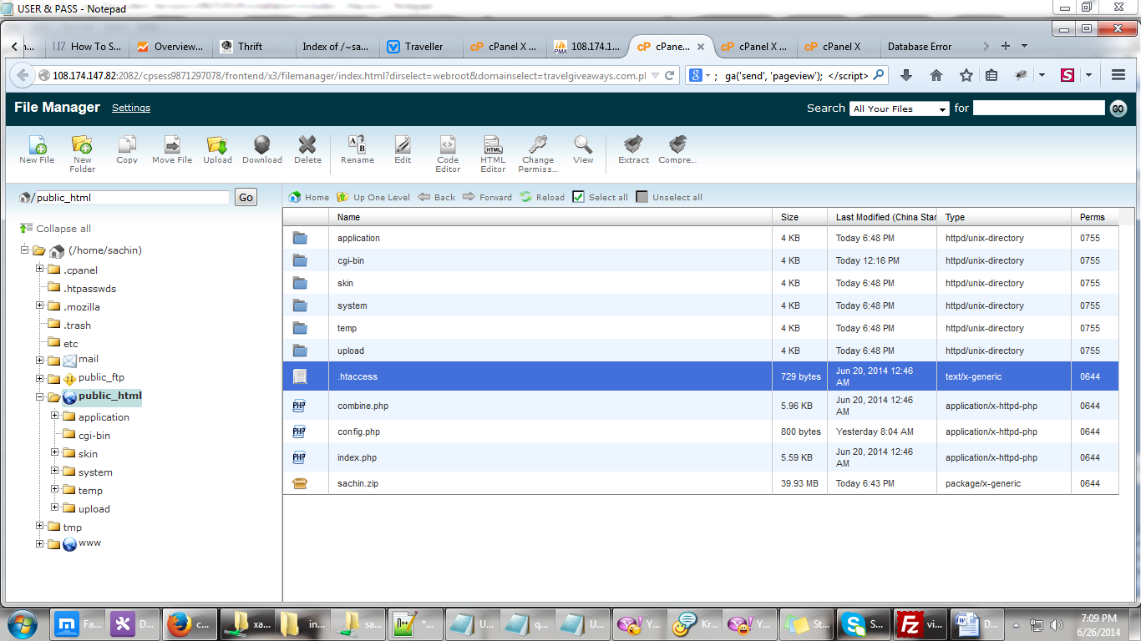 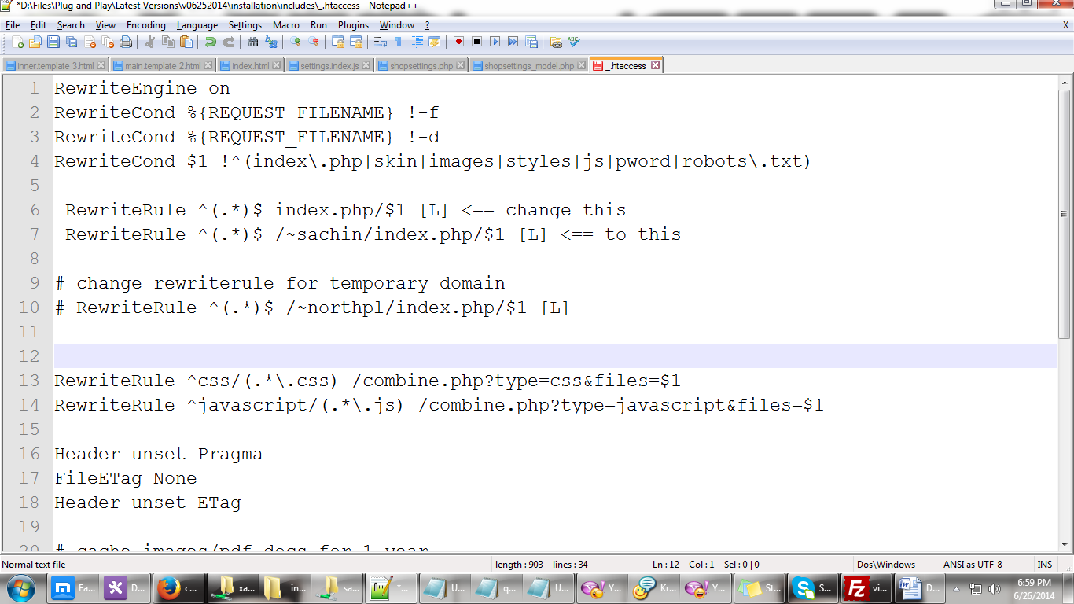

23. Edit config.php 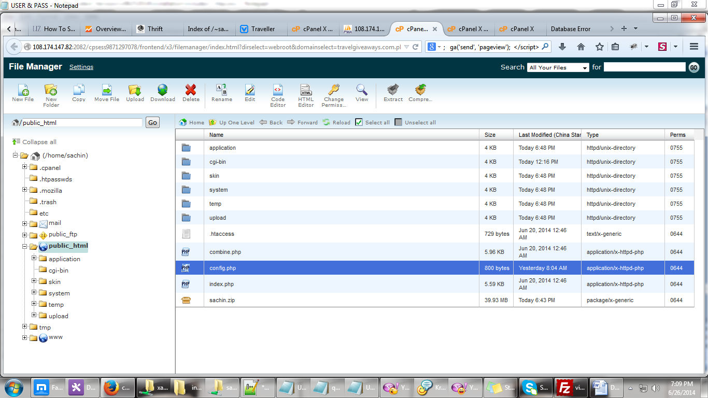

- change the content to this

- 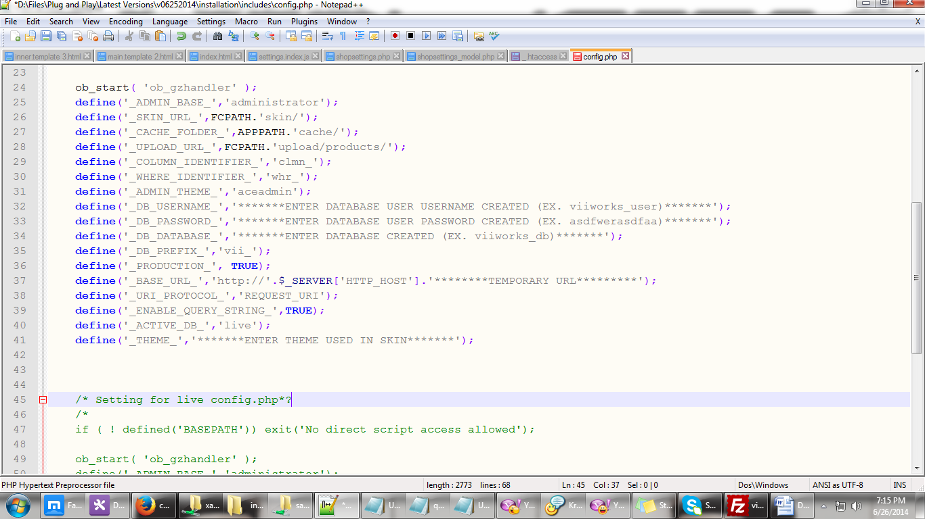

ob_start( 'ob_gzhandler' );

define('_ADMIN_BASE_','administrator');

define('_SKIN_URL_',FCPATH.'skin/');

define('_CACHE_FOLDER_',APPPATH.'cache/');

define('_UPLOAD_URL_',FCPATH.'upload/products/');

define('_COLUMN_IDENTIFIER_','clmn_');

define('_WHERE_IDENTIFIER_','whr_');

define('_ADMIN_THEME_','aceadmin');

define('_DB_USERNAME_','*******ENTER DATABASE USER USERNAME CREATED (EX. viiworks_user)*******');

define('_DB_PASSWORD_','*******ENTER DATABASE USER PASSWORD CREATED (EX. asdfwerasdfaa)*******');

define('_DB_DATABASE_','*******ENTER DATABASE CREATED (EX. viiworks_db)*******');

define('_DB_PREFIX_','vii_');

define('_PRODUCTION_', TRUE);

define('_BASE_URL_','http://'.$_SERVER['HTTP_HOST']. ’/’.'********TEMPORARY URL*********'.’/’); define('_URI_PROTOCOL_','REQUEST_URI');

define('_ENABLE_QUERY_STRING_',TRUE);

define('_ACTIVE_DB_','live');

define('_THEME_','*******ENTER THEME USED IN SKIN*******');